Chapter 2. Experimental section

**2. Experimental section**

The details of the preparation and characterization of 4′-substituted 2-benzylidene-1,3-indandiones, 4’-substituted 5-benzylidenebarbituric acids and 4′-substituted (E)-1-(furan-2-yl)-3-phenylprop-2-ene-1-ones are described in this chapter.

**2.1 Preparation of 4′-substituted 2-benzylidene-1,3-indandiones.**

2-benzylidene-1,3-indandione and its substituted compounds were prepared by the reported procedure.1 To the calculated amount of the appropriate benzaldehyde (12.5 mM) and 1,3-indandione (12.5 mM) in warm ethyl alcohol was added a 10% solution of sodium hydroxide (catalytic amount) and the reaction mixture stirred for 2 h to 3 h and left overnight (Scheme 2.1). The solvent was removed under vacuum. The resulting crude product was purified by column chromatography.



Scheme 2.1

**2.1.1 Characterization**

All chemicals used were purchased from Sigma Aldrich. The purity of the compounds was checked by TLC on silica gel G plates. All the compounds were characterized as 2-benzylidene-1,3-indandione and its derivatives (Fig.2.1) by UV-Visible, FT-IR and NMR spectral techniques. UV-Visible spectra were recorded on a CARY VARION (V 550), CHCl3 was used as a solvent. Infrared spectra were obtained on a PARAGON 500 spectrometer on KBr pellets. 1H and 13C spectra were obtained on a BRUKER AMX 400 MHz spectrometer. The chemical shift of 1H was measured with the peak of CDCl3 at δ 7.29 as the internal reference, while those of 13C were recorded with the central peak of CDCl3 at δ 77.03 as the internal reference.



**Figure 2.1**

where X is the substituents viz. -OMe, -Me, -H, -Cl, -Br, and -COOH

**2.1.2 UV-visible spectral characterization**

UV-Visible absorption spectra were recorded for all the compounds and CHCl3 was used as a solvent. λmax values for various 4′-substituted 2-benzylidene-1,3-indandiones are given in Table (2.1).

**Table 2.1:** λmax values for various 4′-substituted 2-benzylidene-1,3-indandiones in CHCl3.

|  |  |  |
| --- | --- | --- |
| S.No. | Substituent X | nm |
|  |  |  |
| 1. | -OCH3 | 252,386 |
| 2. | -CH3 | 264,357 |
| 3. | -H | 264,345 |
| 4. | -Cl | 265,351 |
| 5. | -Br | 265,353 |
| 6. | -COOH | 263,340 |

**2.1.3. FT-IR Spectra Characterization**

FT-IR (KBr pellets) spectral data of 4′-substituted 2-benzylidene-1,3-indandiones

are given below.

1. **2-(4′-Methoxybenzylidene)-1,3-indandione:** 3439.07, 2839.62,1581.14, 1555.70, 1505.89, 1266.32, 1174.91, 1022.34, 839.46, 731.99, 526.21 cm-1.
2. **2-(4′-Methylbenzylidene)-1,3-indandione:** 3489.89, 1725.29,1683.93, 1588.08, 1373.46, 1351.89,1332.42, 1189.24,1080.52, 989.52,818.12,739.74 cm-1.
3. **2-Benzylidene-1,3-indandione:** 3783.09,3063.50,2364.96,1724.93,1683.75,1586.17,

1376.53,1345.96,1244.02,1198.94,981.07,732.69,682.38,568.09 cm-1.

4. **2-(4′-Chlorobenzylidene)-1,3-indandione:** 3696**.**20,3092.11,2363.08, 1726.37,

1689.99, 1609.80, 1582.35, 1486.02, 1411.93, 1203.63, 1092.42,1074.32, 830.56 cm-1.

5. **2-(4′-Bromobenzylidene)-1,3-indandione:** 3086.69, 1726.98, 1689.61, 1612.90,

1577.50, 1408.55, 1485.35, 1248.20,1202.37,1162.92,1072.53,828.32,736.35 cm-1.

6. **2-(4′-Carboxybenzylidene)-1,3-indandione:** 2825.28,2549.02, 1731.80, 1687.05,

1618.67,1592.13, 1428.79, 1293.26, 1248.65, 1202.53, 1156.73, 988.89, 734.01 cm-1.

**2.1.4. Assignment of 1H NMR Chemical shifts**

In 1H NMR spectra of 2-benzylidene-1,3-indandione, whose signals assignment were quite complicated, the ethylene proton is well separated from the signals of the aromatic protons because of the β-proton nearest to the aromatic ring will experience a magnetic field from the induced circulation of π-electrons in the aromatic ring, which will augment the applied field and hence will lead to down field shift.

All the aromatic protons are deshielded because of ring current effect. Assignment of the signals was based on splitting pattern and peak integration ratio. 1H NMR spectra of 4′-substituted 2-benzylidene-1,3-indandiones are given in Figs. (2.2 – 2.7). 1H NMR chemical shift data for

2-benzylidene-1,3-indandiones are given below.

1. **2-(4′-Methoxybenzylidene)-1,3-indandione: δ** 3.917(s,3H), 6.998-7.027(m,2H), 7.766-7.842(m,2H), 7.842(s,1H),7.958-8.000(m,2H), 8.529-8.558(m,2H).
2. **2-(4′-Methylbenzylidene)-1,3-indandione: δ** 2.343(s,3H), 7.178(d,2H), 7.689 -7.710

(m,2H), 7.766(s,1H), 7.899(dd,1H), 8.287(d,1H).

3. **2-Benzylidene-1,3-indandione: δ** 7.519-7.580(m,4H), 7.824-7.846(m,2H), 7.9249(s,1H),

8.020-8.047(m,2H), 8.465-8.4869(dd,2H).

4. **2-(4′-Chlorobenzylidene)-1,3-indandione: δ** 7.474-7.495(m,2H), 7.834-7.848(m,2H),

7.827(s,1H), 7.997-8.018(m,2H), 8.417-8.438(m,2H).

5. **2-(4′-Bromobenzylidene)-1,3-indandione: δ** 7.640-7.662(dd,2H), 8.322-8.353(dd,2H),

7.811(s,1H), 8.011-8.035(m,2H), 7.829-7.851(m,2H).

6. **2-(4′-Carboxybenzylidene)-1,3-indandione: δ** 7.851(s,1H), 7.902-7.923(m,2H), 7.955-

7.992(m,2H), 8.039(d,2H), 8.465(d,2H).

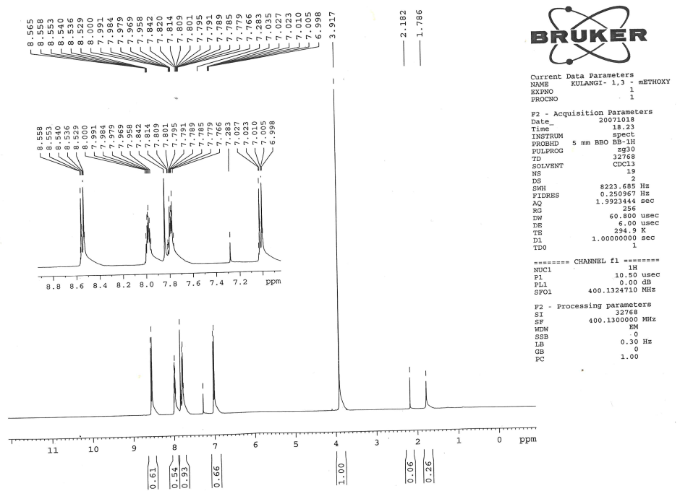

**Figure 2.2.** 1H NMR spectrum of 2-(4′-methoxybenzylidene)-1,3-indandione

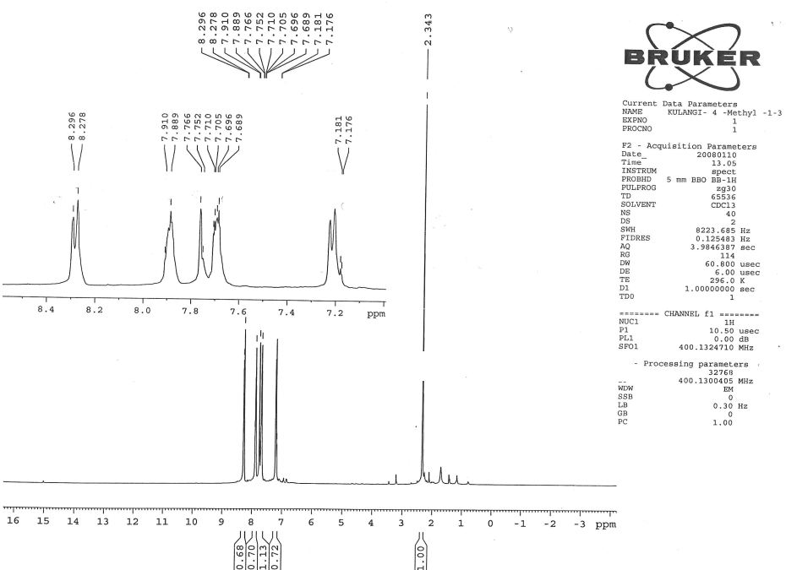

**Figure 2.3** 1H NMR spectrum of 2-(4′-methylbenzylidene)-1,3-indandione

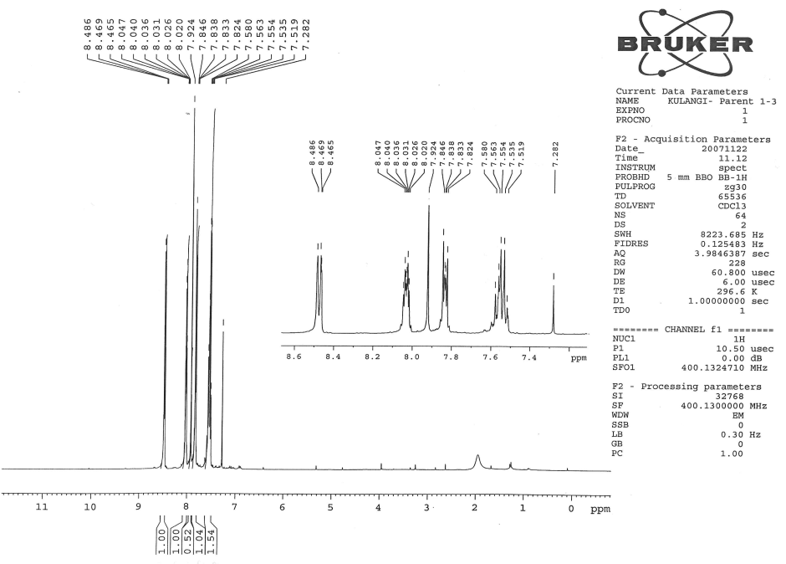

**Fig.2.16** **1H NMR spectrum of** **2-benzylidene-1,3-indandione**

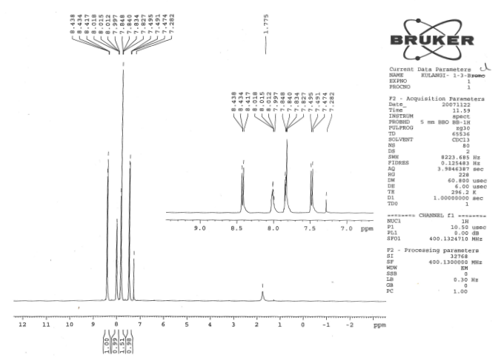

**Figure 2.4**  1H NMR spectrum of 2-benzylidene-1,3-indandione

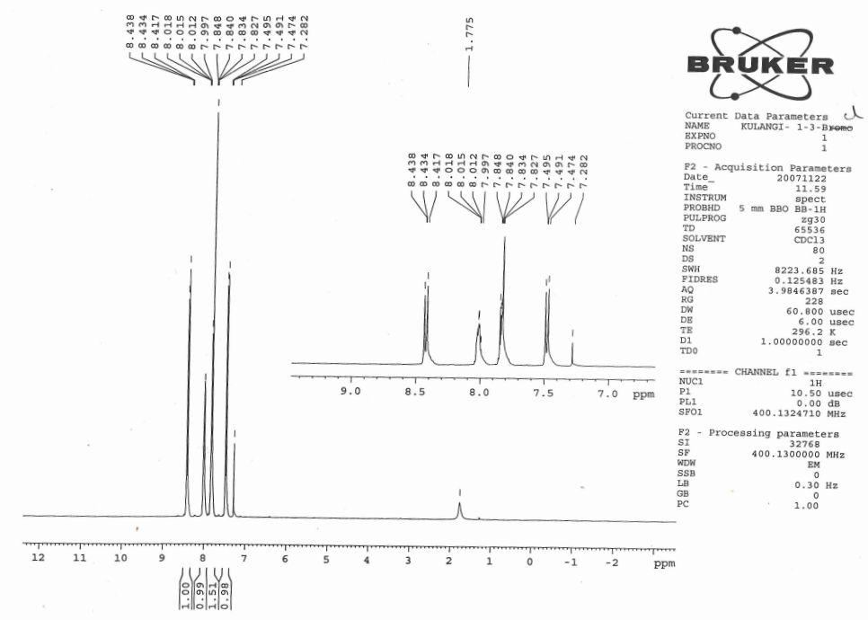

**Figure 2.5**  1H NMR spectrum of 2-(4′-chlorobenzylidene)-1,3-indandione

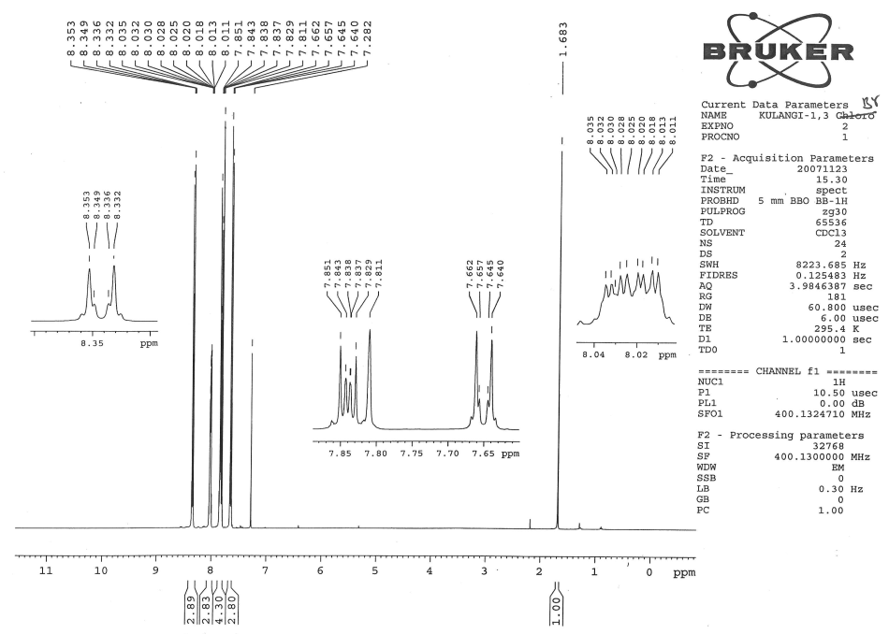

**Figure 2**.**6** 1H NMR spectrum of 2-(4′-bromobenzylidene)-1,3-indandione

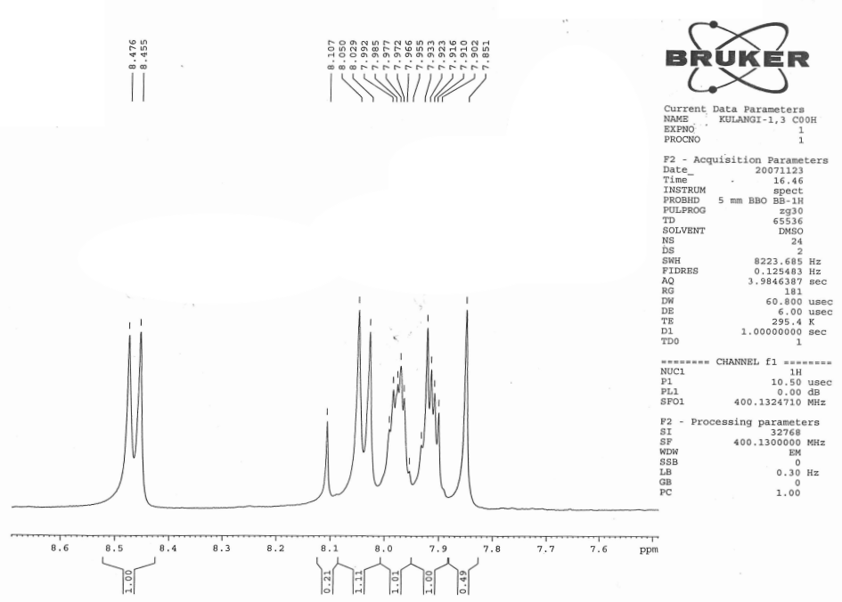

**Figure 2.7**  1H NMR spectrum of 2-(4′-carboxybenzylidene)-1,3-indandione

**2.1.5. Assignment of 13C NMR signals**

13C NMR signals, assigned for various carbons were based on the

1. Chemical shift exhibited by the signals.
2. Relative signal intensity.

13C chemical shifts were assigned by intensity and SCS consideration. 13C NMR spectra of 4′-substituted 2-benzylidene-1,3-indandiones are given in Figures (2.8 - 2.13). The proton-noise decoupled spectrum of parent compound contains 14 signals corresponding to 14 different carbon atoms. In all the spectra, the two carbonyl carbon signals were readily recognized from their low intensity and also well separated from other signals to the downfield extreme, since their assignment was not difficult.

One up field signal was assigned to C7′ carbon atom at 135.45 ppm. The intensity was somewhat larger. The C6 carbon gives a peak at 135.25 ppm.

13C NMR spectral data of 4′-substituted 2-benzylidene-1.3-indandiones are given below.

1. **2-(4′-Methtoxybenzylidene)-1,3-indandione: δ** 55.60, 114.38, 123.07, 126.46, 126.54,

134.87, 135.08, 137.23, 139.94, 142.36, 146.86, 164.05, 189.54, 190.86.

1. **2-(4′-Methylbenzylidene)-1,3-indandione: δ** 22.01, 123.22, 128.17, 129.64, 130.63,

134.49, 135.04, 135.26, 139.99, 142.47, 144.67, 147.10, 189.20, 190.53.

3. **2-Benzylidene-1,3-indandione: δ** 123.36, 123.39, 128.82, 129.17, 133.09, 133.22, 134.18,

135.25, 135.45, 140.06, 142.54, 147.02, 189.04, 190.32.

4. **2-(4′-Chlorobenzylidene)-1,3-indandione: δ** 123.40, 123.44, 129.14, 129.44, 131.54,

135.39, 139.52, 140.07, 142.50, 145.20, 189.01, 189.98.

5. **2-(4′-Bromobenzylidene)-1,3-indandione: δ** 123.44, 128.37, 129.63, 131.91, 132.16,

135.41, 135.57, 140.08, 142.52, 145.27, 189.01, 189.96.

6. **2-(4′-Carboxybenzylidene)-1,3-indandione: δ** 123.55, 123.64, 129.70, 131.11, 133.76,

134.37, 136.25, 136.36, 136.64, 140.05, 142.48, 144.36, 167.05, 188.60, 189.34.

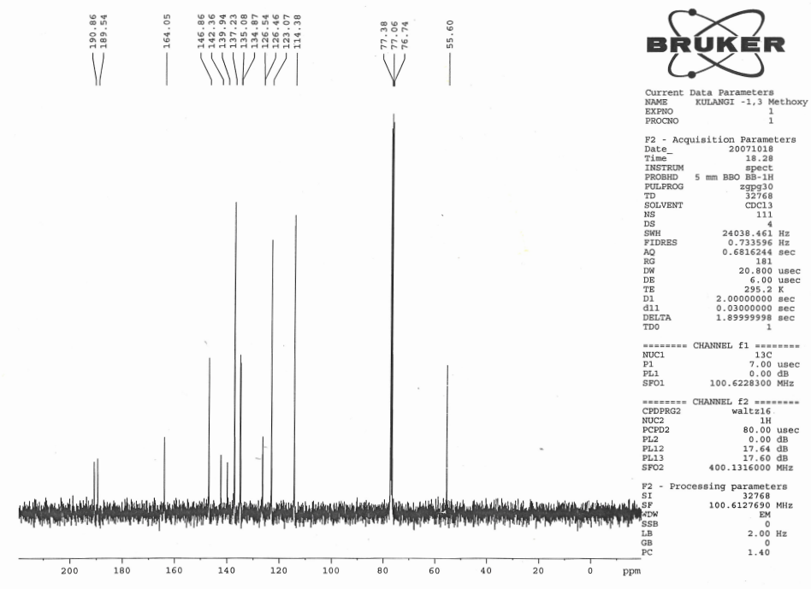

**Figure 2.8** 13C NMR spectrum of 2-(4′-methtoxybenzylidene)-1,3-indandione

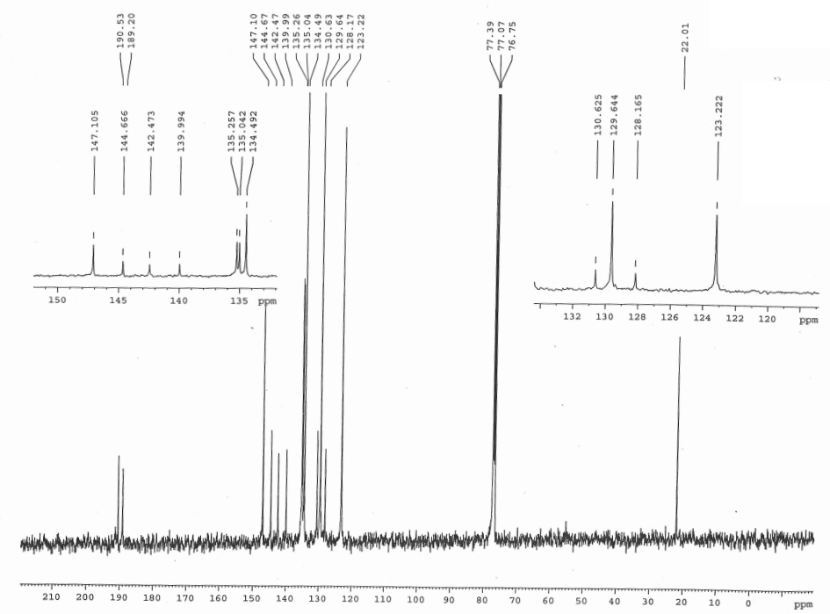

**Figure 2.9** 13C NMR spectrum of 2-(4′-methylbenzylidene)-1,3-indandione

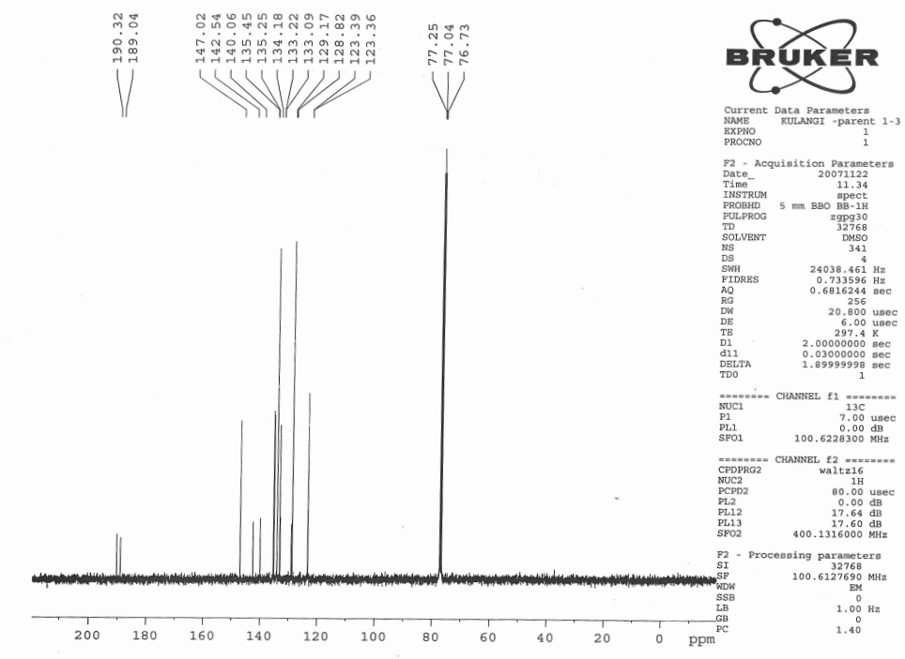

**Figure 2.10**  13C NMR spectrum of 2-benzylidene-1,3-indandione



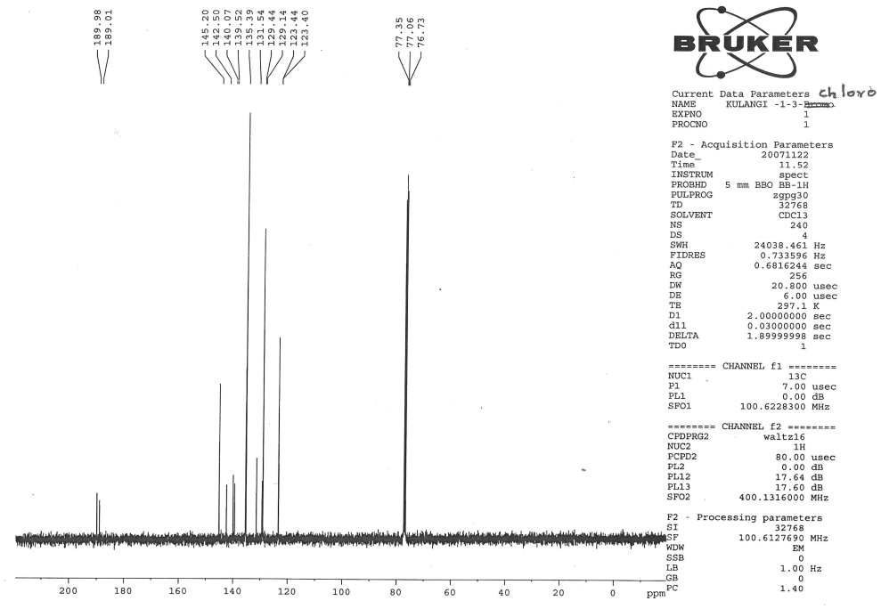

**Figure 2.11**  13C NMR spectrum of 2-(4′-chlorobenzylidene)-1,3-indandione

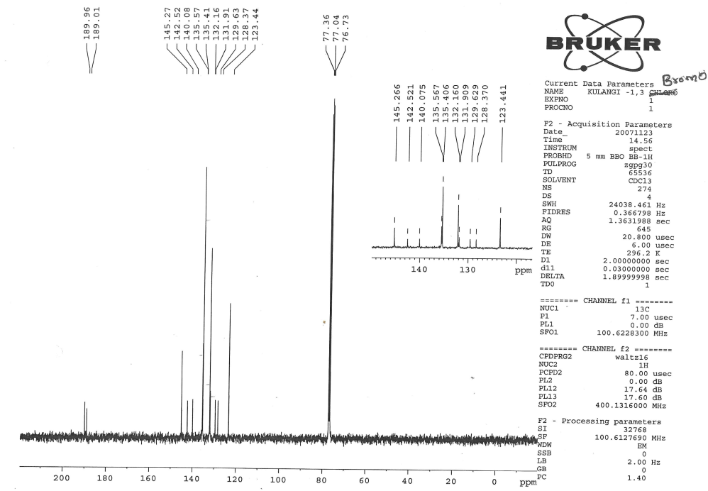

**Figure 2.12**  13C NMR spectrum of 2-(4′-bromobenzylidene)-1,3-indandione

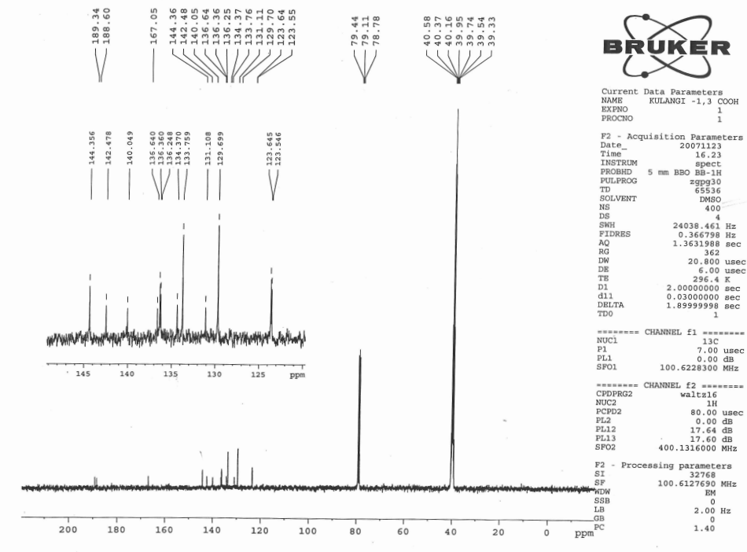

**Figure 2.13**  13C NMR spectrum of 2-(4′-carboxybenzylidene)-1,3-indandione

**2.2 Preparation of 4′-substituted 5-benzylidenebarbituric acids.**

5-benzylidenebarbituric acid and its substituted compounds were prepared by the modified procedure2.

To the calculated amount of the pure benzaldehyde (2 g, 0.015 mol) and barbituric acid (1.55 g, 0.015 mol) in warm ethyl alcohol was added a 10% solution of sodium hydroxide (catalytic amount) and the reaction mixture stirred for 2 hours. After completion of the reaction as indicated by TLC, the reaction mixture was left overnight (Scheme 2.2). The solvent was removed in vacuum. The resulting crude product was purified by column chromatography.



**Scheme 2.2**

**2.2.1 Characterization**

All the compounds were characterized as 5-benzylidenebarbituric acid and its derivatives (Fig.2.14) by 1H and 13C NMR spectral techniques. 1H and 13C spectra were obtained on a BRUKER AMX 400 MHz spectrometer. Chemical shifts of 1H were measured with the peak of DMSO at δ 2.51 as the internal reference, while those of 13C were recorded with the central peak of DMSO at δ 39.90 as the internal reference.



**Figure 2.14**

**2.2.2 Assignment of 1H NMR Signals**

In 1H NMR spectrum of 5-benzylidenebarbituric acid, signals assignment was not difficult and all signals were well separated from each other. The two different NH-protons are expected to downfield than the -CH-proton of C7 carbon atom. The -CH-proton of C7 is well separated from all other protons signals, hence it’s assignment is not difficult. 1H NMR spectra of 4′-substituted 5-benzylidenebarbituric acids are given in Figs. (2.15 – 2.21).

**1H NMR Spectral data of 4′-substituted 5-benzylidenebarbituric acids are given below.**

1. **5-(4′-Methoxybenzylidene)barbituric acid**

**δ** 3.877 (s,3H), 7.065 (d,2H), 8.252(s,1H), 8.369 (d,2H), 11.175 (s,1H), 11.302 (s,1H).

2. **5-(4′-Hydroxybenzylidene)barbituric acid**

**δ** 6.878 (d,2H), 8.213 (s,1H), 8.320 (d,2H), 10.851 (s,1H), 11.117(s,1H), 11.249 (s,1H).

3. **5-(4′-Methylbenzylidene)barbituric acid**

**δ** 2.385 (s,3H), 7.304 (d,2H), 8.094 (d,2H), 8.255 (s,1H), 11.218 (s,1H), 11.365 (s,1H).

4. **5-Benzylidenebarbituric acid**

**δ** 7.485 (m,3H), 8.073 (d,2H), 8.285 (s,1H), 11.238 (s,1H), 11.397 (s,1H).

5. **5-(4′-Chlorobenzylidene)barbituric acid**

**δ** 7.518 (d,2H), 8.069 (d,2H), 8.243 (s,1H), 11.275 (s,1H), 11.425 (s,1H).

6. **5-(4′-Bromobenzylidene)barbituric acid**

**δ** 7.670 (d,2H), 7.979 (d,2H), 8.223 (s,1H), 11.272 (s,1H), 11.421 (s,1H).

7. **5-(4′-Nitrobenzylidene)barbituric acid**

**δ** 8.017 (d,2H), 8.245 (d,2H), 8.324 (s,1H), 11.329 (s,1H), 11.504 (s,1H).

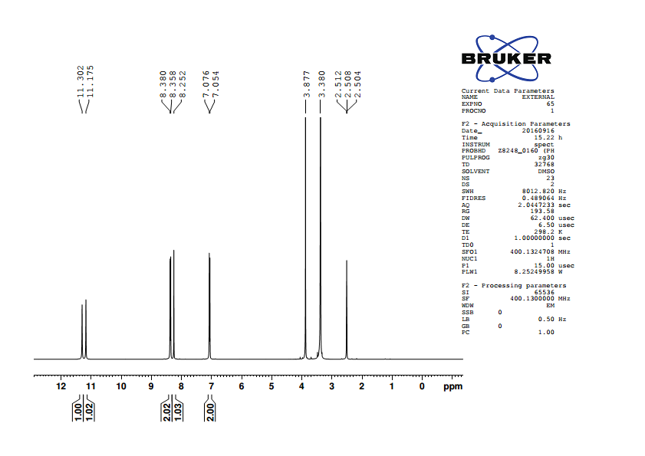

**Figure 2.15** 1H NMR spectrum of 5-(4′-methoxybenzylidene)barbituric acid

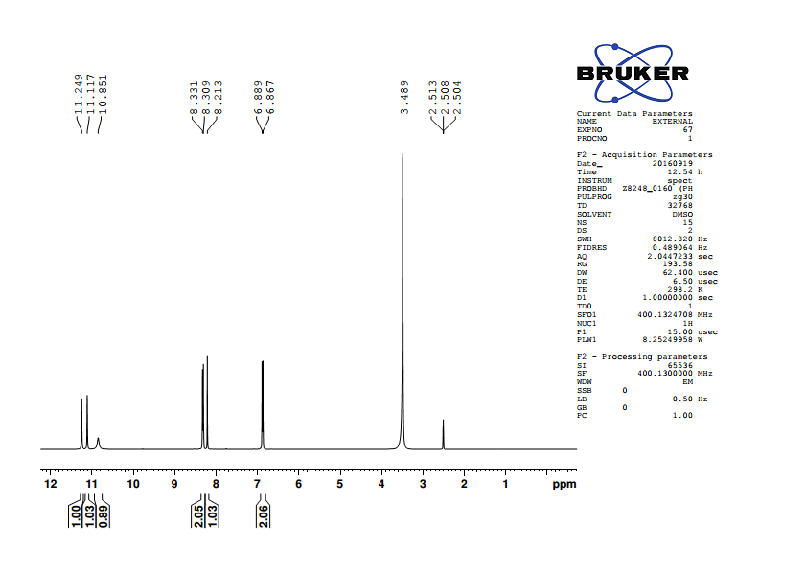

**Figure 2.16** 1H NMR spectrum of 5-(4′-hydroxybenzylidene)barbituric acid

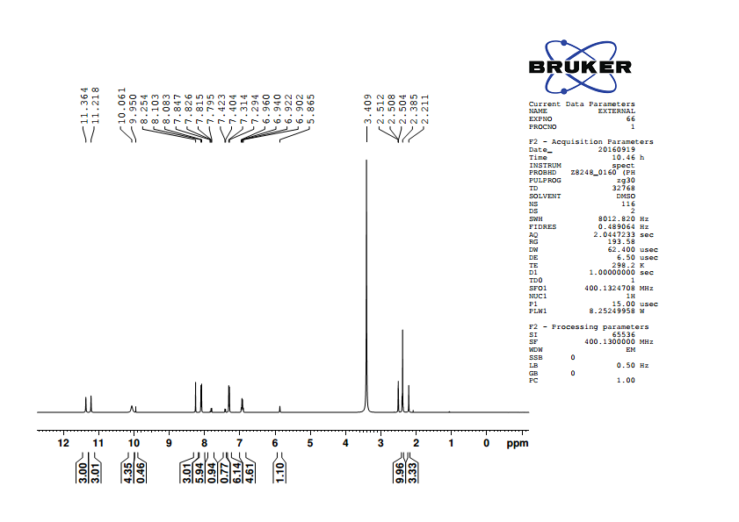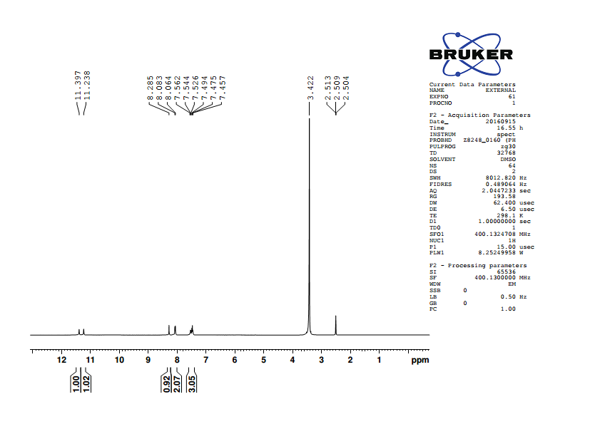

**Figure 2.17** 1H NMR spectrum of 5-(4′-methylbenzylidene)barbituric acid

**Figure 2.18** 1H NMR spectrum of 5-benzylidenebarbituric acid

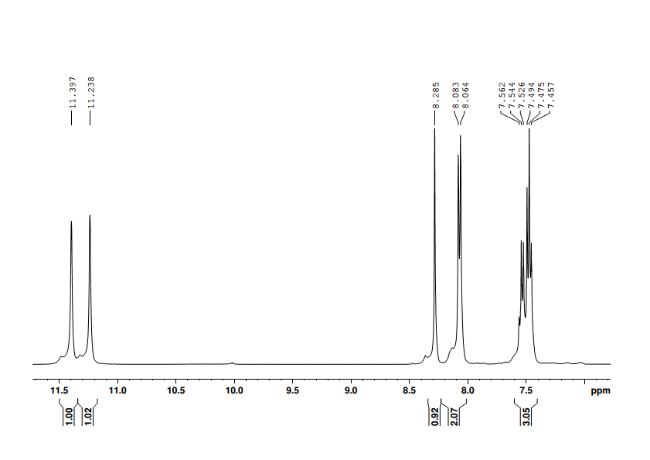

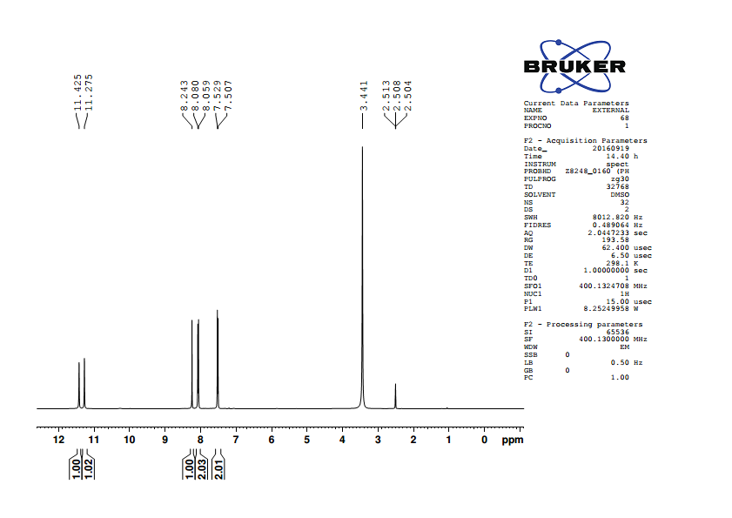

**Figure 2.**1**9** 1H NMR spectrum of 5-(4′-chlorobenzylidene)barbituric acid

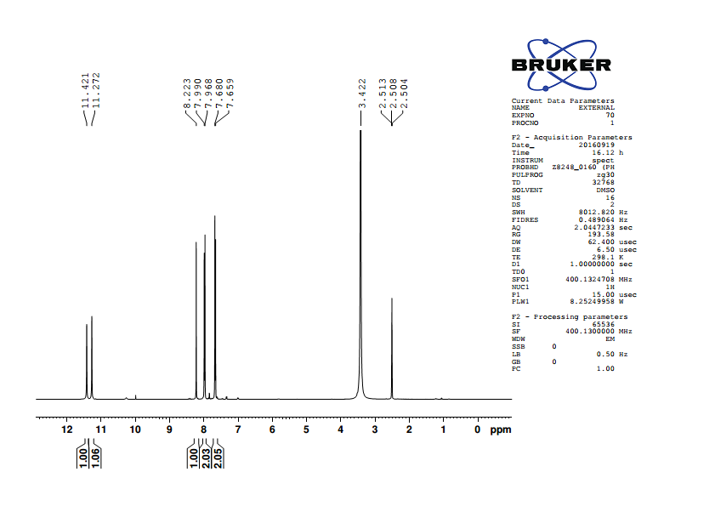

**Figure 2.20** 1H NMR spectrum of 5-(4′-bromobenzylidene)barbituric acid

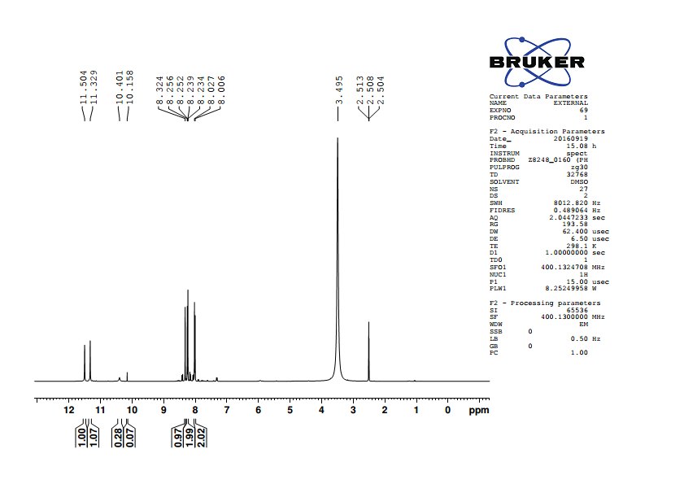

**Figure 2.21** 1H NMR spectrum of 5-(4′-nitroobenzylidene)barbituric acid

**2.2.3 Assignment of 13C NMR signals**

13C NMR signals assigned for various carbons were based on the

1. Chemical shift exhibited by the signals
2. Relative signal intensity
3. Empirical additivity rules

13C NMR spectrum of 5-benzylidenebarbituric acid contains 9 signals corresponding to 9 different carbon atoms. In all the spectra, carbonyl carbon signal was readily recognized and also well separated from other signals to the downfield extreme, since its assignment was not difficult. 13C NMR spectra of 4’-substituted 5-benzylidenebarbituric acids are given in Figs. (2.22 - 2.28).

13C NMR Spectral data of 4′-substituted 5-benzylidenebarbituric acids are given below.

1***.* 5-(4′-Methoxybenzylidene)barbituric acid**

**δ** 56.22, 114.41, 116.00, 125.62, 137.96, 150.67, 155.46, 162.64, 163.92, 164.39.

2. **5-(4′-Hydroxybenzylidene)barbituric acid**

**δ** 114.61, 115.97, 124.24, 138.77, 150.70, 156.05, 162.75,163.48, 164.59.

3. **5-(4′-Methylbenzylidene)barbituric acid**

**δ** 118.30, 129.33, 130.31, 134.43, 143.96, 150.68, 155.46, 162.26, 164.08.

4. **5-Benzylidenebarbituric acid**

**δ** 119.55, 128.52, 132.69, 133.11, 133.54, 150.69, 155.20, 162.03, 163.87.

5. **5-(4′-Chlorobenzylidene)barbituric acid**

**δ** 120.09, 128.55, 132.01, 135.15, 137.21, 150.65, 153.52, 162.04, 163.67.

6. **5-(4′-Bromobenzylidene)barbituric acid**

**δ** 120.24, 126.29, 131.51, 132.40, 135.15, 150.65, 153.56, 162.04, 163.67.

7. **5-(4′-Nitrobenzylidene)barbituric acid**

**δ** 123.15, 123.37, 132.69, 140.48, 148.49, 150.68, 151.63, 161.62, 163.13.

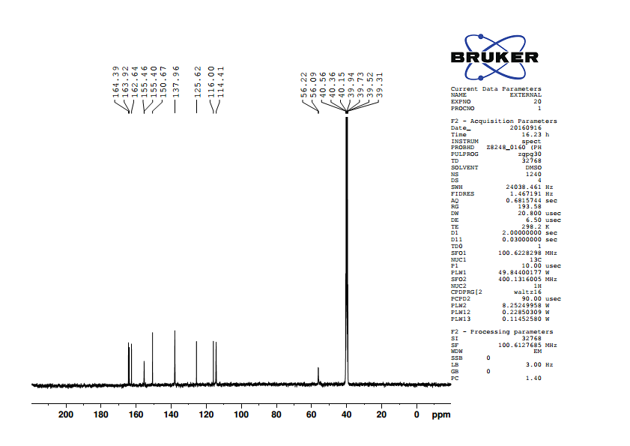

**Figure 2.22** 13C NMR spectrum of 5-(4′-methoxybenzylidene)barbituric acid

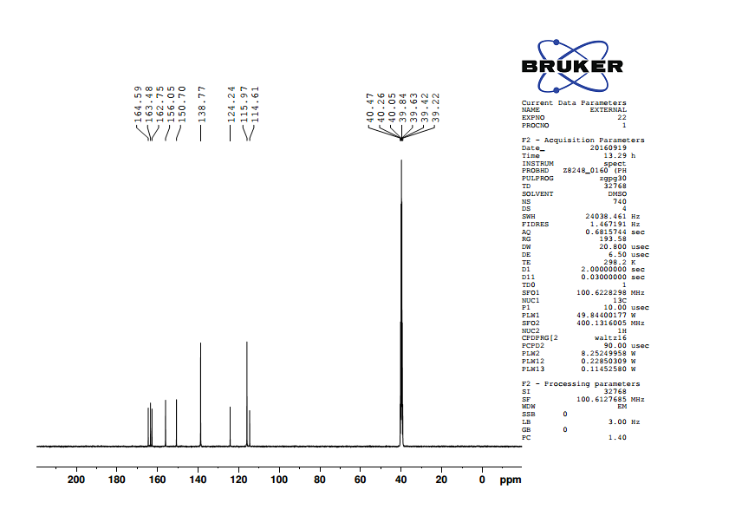

**Figure 2.23** 13C NMR spectrum of 5-(4′-hydroxybenzylidene)barbituric acid

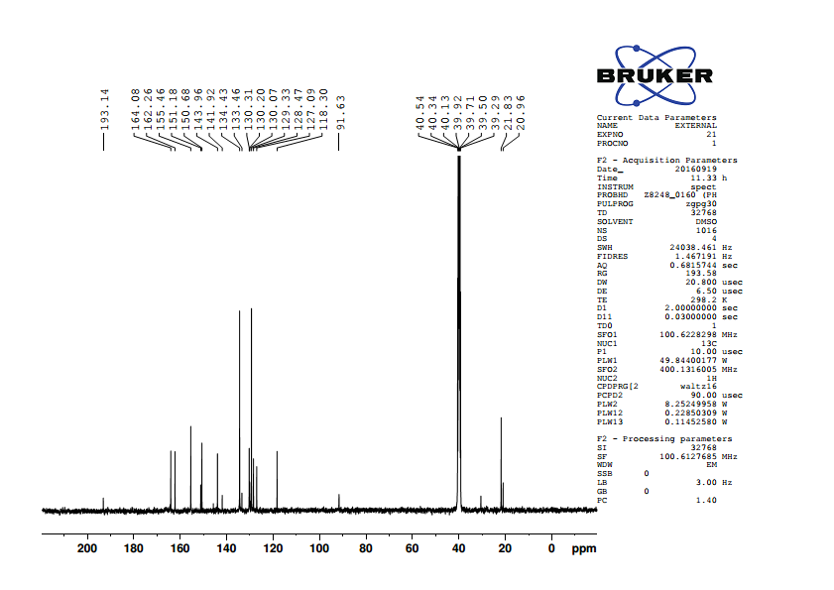

**Figure 2.24** 13C NMR spectrum of 5-(4′-methylbenzylidene)barbituric acid

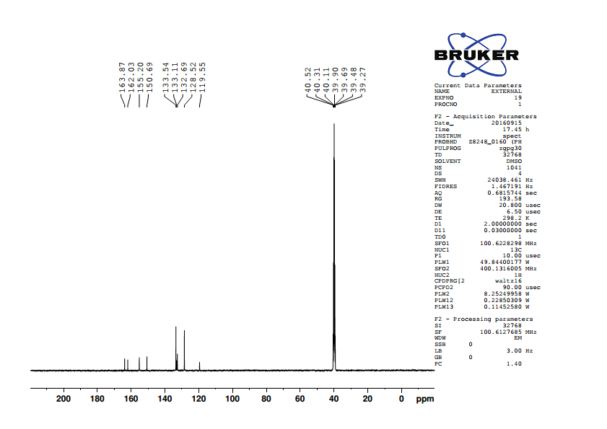

**Figure 2.25** 13C NMR spectrum of 5-benzylidenebarbituric acid

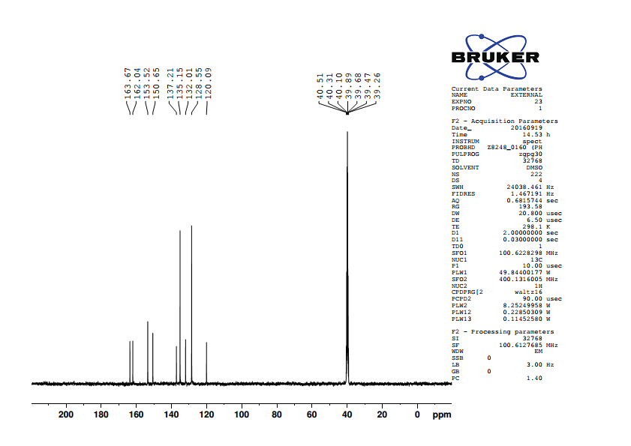

**Figure 2.26** 13C NMR spectrum of 5-(4′-chlorobenzylidene)barbituric acid

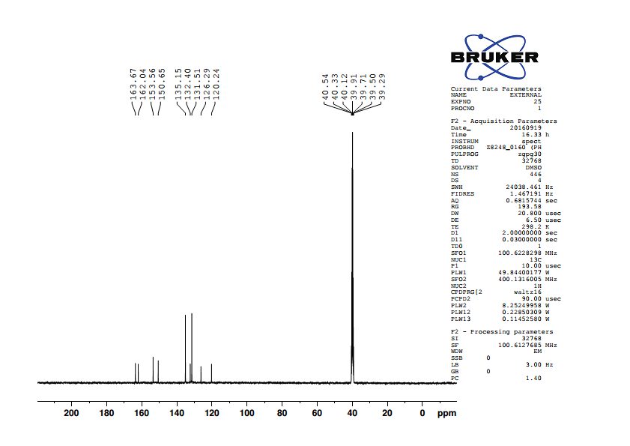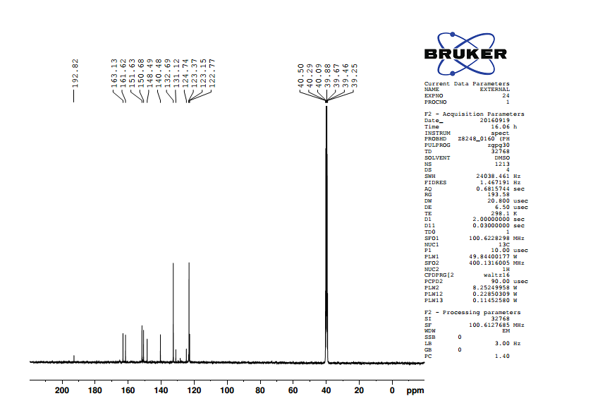

**Figure 2.27** 13C NMR spectrum of 5-(4′-bromobenzylidene)barbituric acid

**Figure 2.28** 13C NMR spectrum of 5-(4′-nitrobenzylidene)barbituric acid

**2.3 Preparation of 4′-substituted (E)-1-(furan-2-yl)-3-phenylprop-2-ene-1-one**.

(E)-1-(Furan-2-yl)-3-phenylprop-2-ene-1-one and its4′-substituted compounds were prepared by the following procedure.3

The mixture of the calculated amount of the pure 2-acetylfuran (0.55g ~ 0.005 moles) in cold ethanol and 10% solution of sodium hydroxide (catalytic amount) was cooled in a water bath to 0o C. To this mixture pure benzaldehyde (0.583 g ~ 0.0055 moles) in cold ethanol was added drop by drop for 30 minutes. The reaction mixture stirred for 2 hours. Then it was kept in the refrigerator for overnight (Scheme 2.3). The precipitated solid was collected and recrystallized using ethanol-chloroform (10:1) mixture. All the substituted compounds were prepared by using the above procedure.



**Scheme 2.3**

**2.3.1 Characterization**

All the compounds were characterized as (E)-1-(furan-2-yl)-3-phenylprop-2-ene-1-one and its derivatives (Fig.2.29) by 1H and 13C NMR spectral techniques. All 1H and 13C NMR spectra were obtained on a BRUKER AV 400 MHz spectrometer. Chemical shifts of 1H were measured with the central peak of CDCl3 at δ 7.259 as the internal reference, while those of 13C were measured with the central peak of CDCl3 at δ 77.54 as the internal reference.



**Figure 2.29**

where X is the substituents viz. -NMe2, -Me, H, -Cl, -F, -CHO.

**2.3.2 Assignment of 1H NMR spectra**

In 1H NMR spectra of (E)-1-(furan-2-yl)-3-phenylprop-2-ene-1-ones, signals assignment were not difficult and all signals were well separated from each other. The -CH- proton of furan C5 carbon atom is expected to downfield than -CH- proton of furan C3 carbon atom. The -CH- proton of furan C4  is well separated from all other protons signals, hence it’s assignment is not difficult. Two ethylenic protons C3 and C2 carbon atoms are well separated from each other. The α-ethylenic proton is expected to have downfield shift since it has proximity to the carbonyl group. Assignment of the signals was based on splitting pattern and peak integration ratio. 1H NMR spectra of (E)-1-(furan-2-yl)-3-phenylprop-2-ene-1-ones are given in Figs. (2.30 -2.34).

**1H NMR spectra of (E)-1-(furan-2-yl)-3-phenylprop-2-ene-1-ones are given below.**

1. **(E)-1-(Furan-2-yl)-3-(4′ -N,N dimethylaminophenyl)prop-2-ene-1-one:**

**δ** 3.043(s,6H), 6.562 (d,d,1H), 6.690 (d,2H), 7.256 (d,1H), 7.262 (d,1H),7.554

(d,2H), 7.616 (m,1H), 7.856 (d,1H).

1. **(E)-1-(Furan-2-yl)-3-(4′ -methylphenyl)prop-2-ene-1-one:**

**δ** 7.233(dd,1H), 7.330(d,1H), 7.561(d,2H), 7.421(d,1H), 7.233(d,2H), 7.872(d,1H),

7.656(m,1H), 2.401(s,3H).

1. **(E)-1-(Furan-2-yl)-3-phenylprop-2-ene-1-one:**

**δ** 6.600 (dd,1H), 7.336 (d,1H), 7.421(m.2H), 7.423 (d,1H), 7.456(d,1H), 7.655(m,2H),

**7.**657(m,1H), 7.885(d,1H).

1. **(E)-1-(Furan-2-yl)-3-(4′-chlorophenyl)prop-2-ene-1-one:**

**δ** 6.606(d,d,1H), 7.339(d,1H), 7.394(d,2H), 7.425(d,1H), 7.584(d,2H), 7.584(d,2H),

7.658(m,1H), 7.822(d,1H).

1. **(E)-1-(Furan-2-yl)-3-(4′ -fluorophenyl)prop-2-ene-1-one:**

**δ** 6.599 (dd,1H), 7.107(m,2H), 7.329(d,1H), 7.380(d,1H), 7.642(d,2H), 7.650(m,1H),

7.837(d,1H).

1. **(E)-1-(Furan-2-yl)-3-(4′ -methanoylphenyl)prop-2-ene-1-one:**

**δ** 6.633(d,d 1H), 7.384(d,1H), 7.807(d,2H), 7.566(d,1H), 7.939(d,2H), 7.690(m,1H),

7.895(d,1H), 10.056(s,1H).

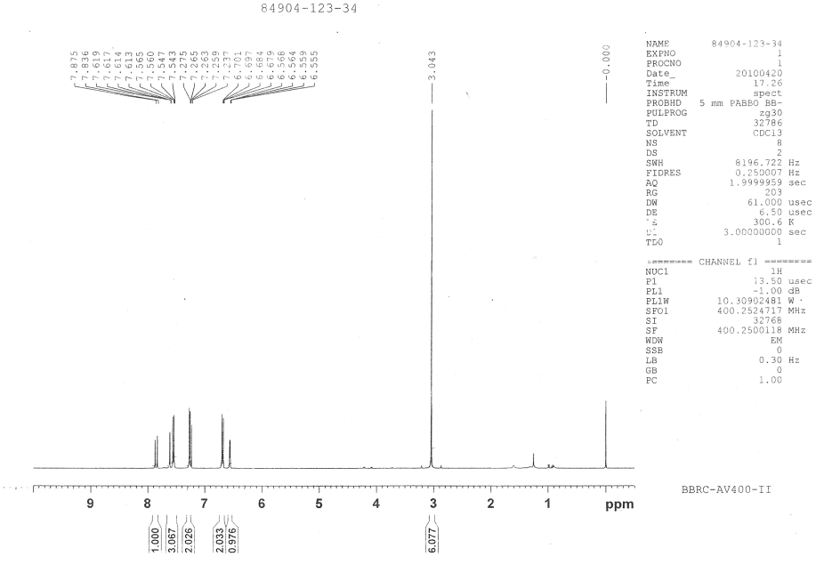

**Figure 2.30**. 1H NMR spectra of (E)-1-(furan-2-yl)-3-(4′ -N,N dimethylaminophenyl)prop-2-ene-1-one

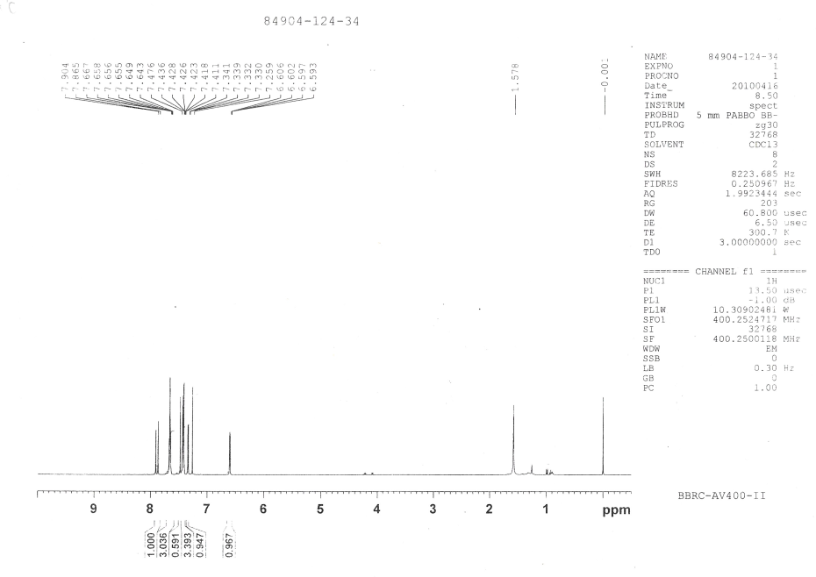

**Fig**ure **2.31** 1H NMR spectra of (E)-1-(furan-2-yl)-3-phenylprop-2-ene-1-one

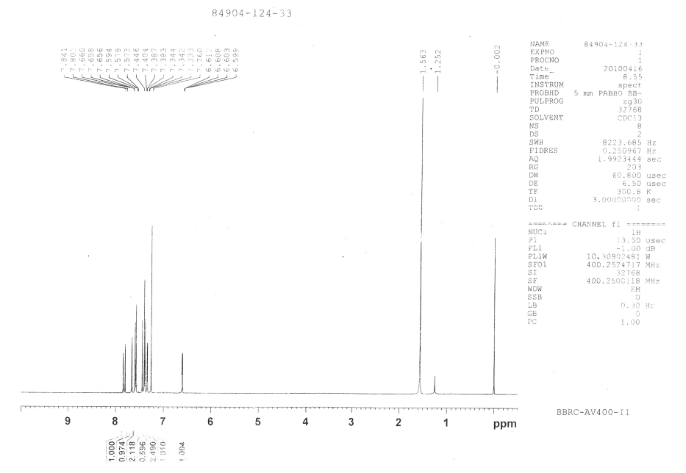

**Figure 2.32** 1H NMR spectra of (E)-1-(furan-2-yl)-3-(4′-chlorophenyl)prop-2-ene-1-one

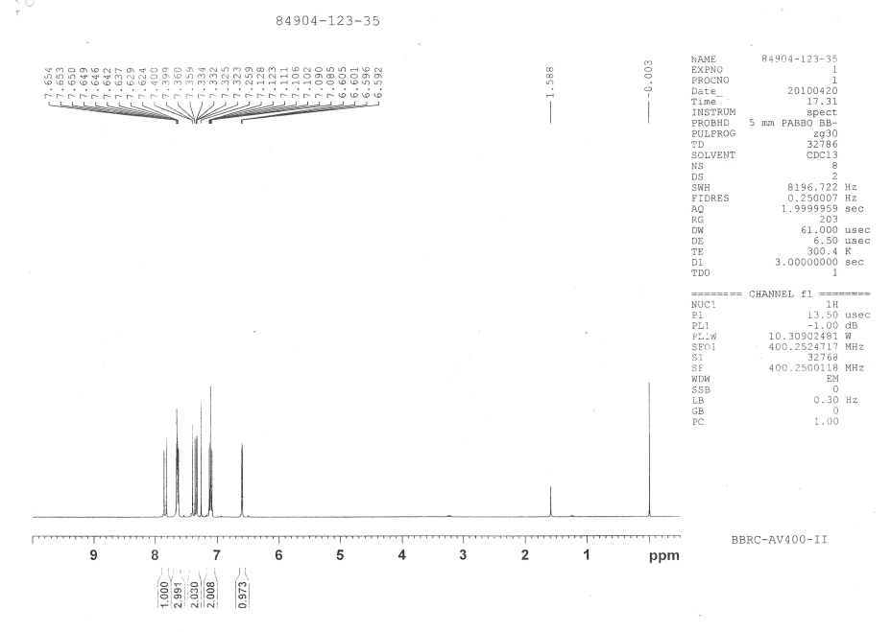

**Figure 2.33** 1H NMR spectra of (E)-1-(furan-2-yl)-3-(4′ -fluorophenyl)prop-2-ene-1-one

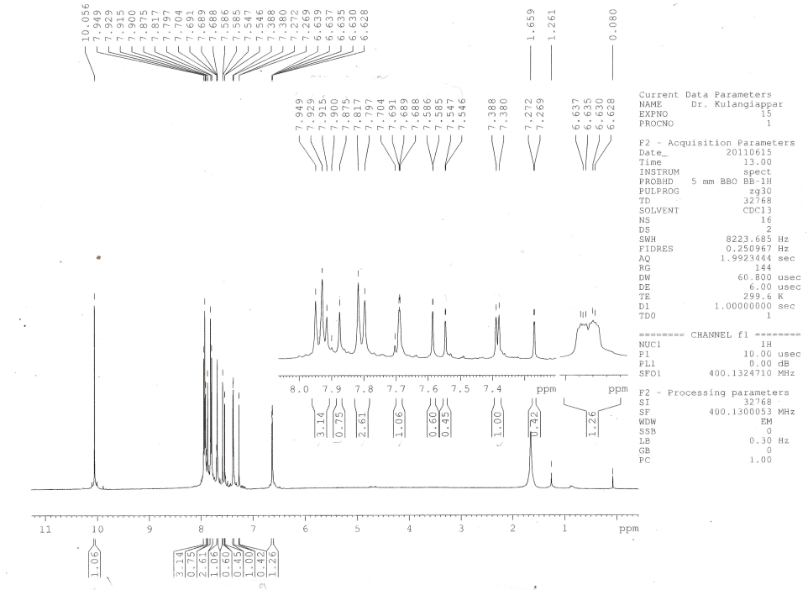

**Figure 2.34** 1H NMR spectra of (E)-1-(furan-2-yl)-3-(4′-methanoylphenyl)prop-2-ene-1-one

**2.3.3 Assignment of 13C NMR signals**

13C NMR signals, assigned for various carbons, were based on the

1. Chemical shift exhibited by the signals
2. Relative signal intensity,
3. Empirical additivity rules.

The proton noise decoupled spectrum of parent compound contains 11 signals corresponding to 11 different carbon atoms. In all the spectra, carbonyl carbon signal was readily recognized from its low intensity and also well separated from other signals to the downfield extreme, since its assignment was not difficult.

Two more low-intensity peaks were readily assigned to furan C2 and C1′ carbon atoms. Due to nearby oxygen atoms in the ring the downfield signal at 153.73 ppm was assigned to furan C2 carbon atom. The up field signal at 134.75 ppm was assigned to C1’ carbon atom.

Remaining eight signals are for eight carbon atoms, in which, six signals appeared with almost same intensity and the other two signals appeared twice in intensity. This is due to the number of protons attached to the sp2 carbon atoms. The two high-intensity signals were readily assigned to aromatic carbon C2′6′ and C3′5′’ atoms. This is due to the styrene as substituent since the upfield signal is 128.54 ppm was assigned for (*ortho*) C3′5′ carbon atom and next downfield signal at 128.96 ppm was assigned for (*meta*) C2′6′ carbon atom.

The remaining are six same intensity signals in which most downfield extreme signals at 146.53 ppm was assigned to furan C5 carbon atom of furan ring because it is directly attached to the oxygen atom.

Among the remaining downfield signals, two upfield signals were assigned to furan C3 and furan C4 carbon atoms. The signal at 117.52 ppm was assigned to furan C3 carbon atom and the signal at 112.56 ppm was assigned to furan C4 carbon atom.

Of the remaining three signals the signal at 121.20 ppm was assigned for aromatic C4′ (*para*) carbon atom.

Remaining other two signals were assigned for (Cβ) C3 and (Cα) C2 carbon atoms. The downfield signal at 144.00 ppm was assigned for C3 carbon atom and the upfield signal at 130.62 ppm was assigned at 130.62 ppm was assigned for C2 carbon atom, this is due to the π-bond polarization α, β unsaturated carbonyl compound.

In *para* substituted derivatives assignments of the benzene ring (C2’6’, C3’5’, C1’, C4’) carbon signals and C2, furan C2 carbon signals somewhat ambiguous in nature, has been removed by empirical additivity rules (Appendix-I) and relative intensity.

13C NMR spectra of 4′-substituted (E)-1-(furan-2-yl)-3-phenylprop-2-ene-1-ones are given in Figs. (2.35 – 2.40). 13C NMR spectral data of 4’-substituted (E)-1-(furan-2-yl)-3-phenylprop-2-ene-1-ones are given below.

1. **(E)-1-(Furan-2-yl)-3-(4′ -N, N dimethylaminophenyl) prop-2-ene-1-one:**

**δ** 111.82, 112.28, 115.94, 116.38, 122.54, 130.53, 144.86, 145.86, 152.10, 154.26,

178.29.

1. **(E)-1-(Furan-2-yl)-3-(4′ -methylphenyl) prop-2-ene-1-one:**

**δ** 112.20, 117.01, 119.89, 128.28, 129.41, 131.74, 140.89, 143.80, 146.10, 153.52,

177.88.

1. **(E)-1-(Furan-2-yl)-3-phenylprop-2-ene-1-one:**

**δ** 112.56, 117.52, 121.20, 128.54, 128.96, 130.62, 134.75, 144.00, 146.53, 153.73,

178.03

1. **(E)-1-(Furan-2-yl)-3-(4′-chlorophenyl) prop-2-ene-1-one:**

**δ** 112.65, 117.65, 121.63, 129.25, 129.67, 133.26, 136.52, 142.48, 146.61, 153.64,

177.76

1. **(E)-1-(Furan-2-yl)-3-(4′ -fluorophenyl) prop-2-ene-1-one:**

**δ** 112.60, 116.02, 116.24, 117.49, 120.93, 130.40, 130.44, 142.66, 146.52, 153.70,

177.85

1. **(E)-1-(Furan-2-yl)-3-(4′-methanoylphenyl) prop-2-ene-1-one:**

**δ** 112.50,117.77,123.68, 128.63, 129.90, 137.03, 140.13, 141.75, 146.58, 153.23,

177.17.

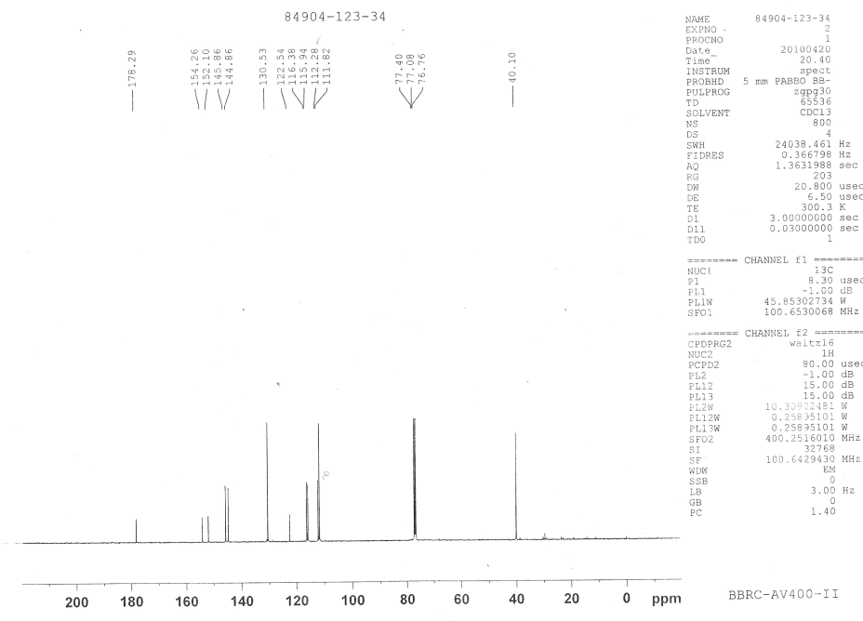

**Figure 2.35** 13C NMR spectra of (E)-1-(furan-2-yl)-3-(4′ -N,N dimethylaminophenyl)prop-2-ene-1-one

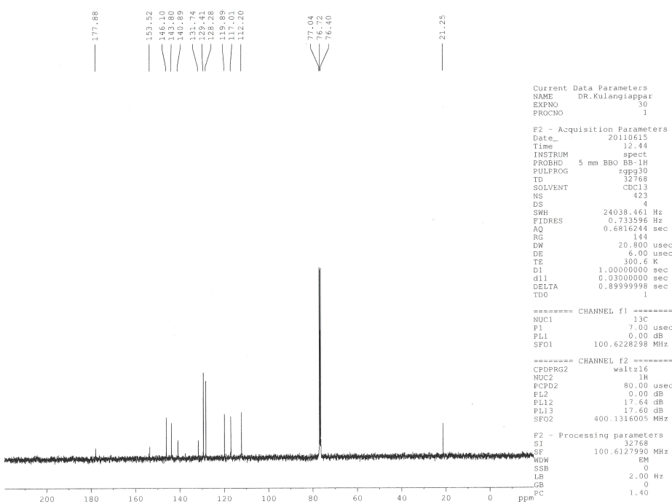

**Figure 2.36** 13C NMR spectra of (E)-1-(furan-2-yl)-3-(4′ -methylphenyl)prop-2-ene-1-one

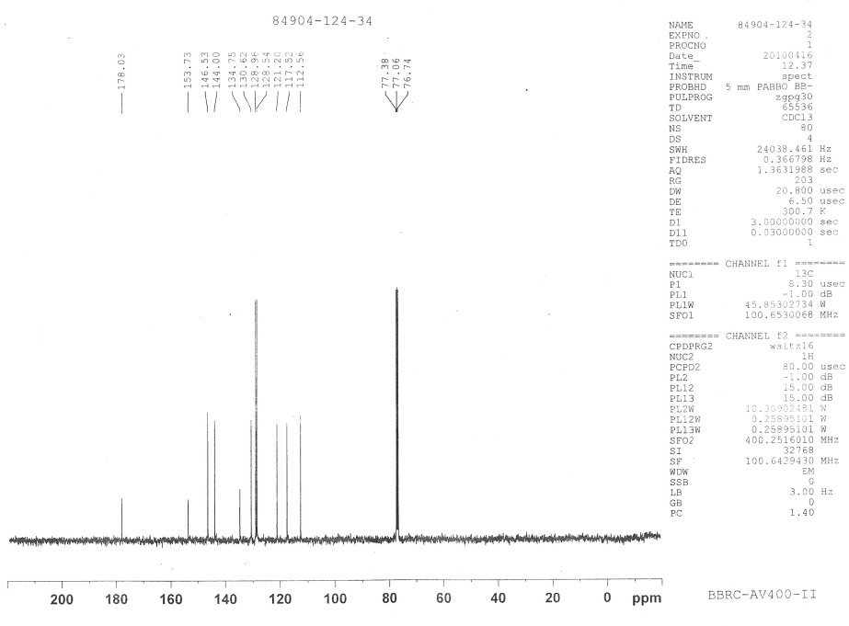

**Figure 2.37** 13C NMR spectra of (E)-1-(furan-2-yl)-3-phenylprop-2-ene-1-one

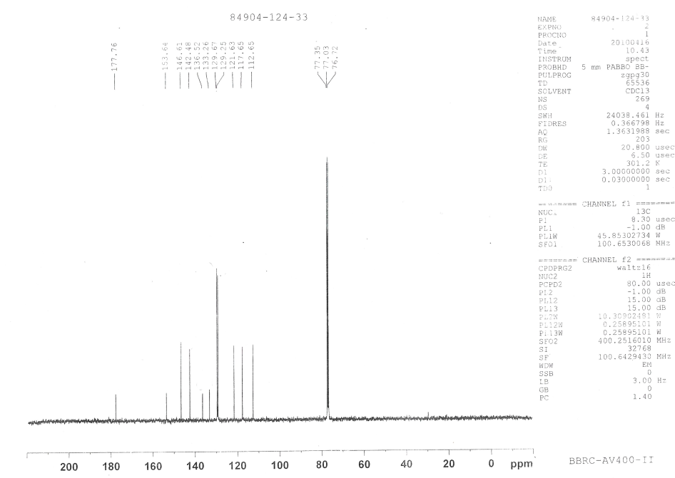

**Figure 2.38**  13C NMR spectra of (E)-1-(furan-2-yl)-3-(4′-chlorophenyl)prop-2-ene-1-one

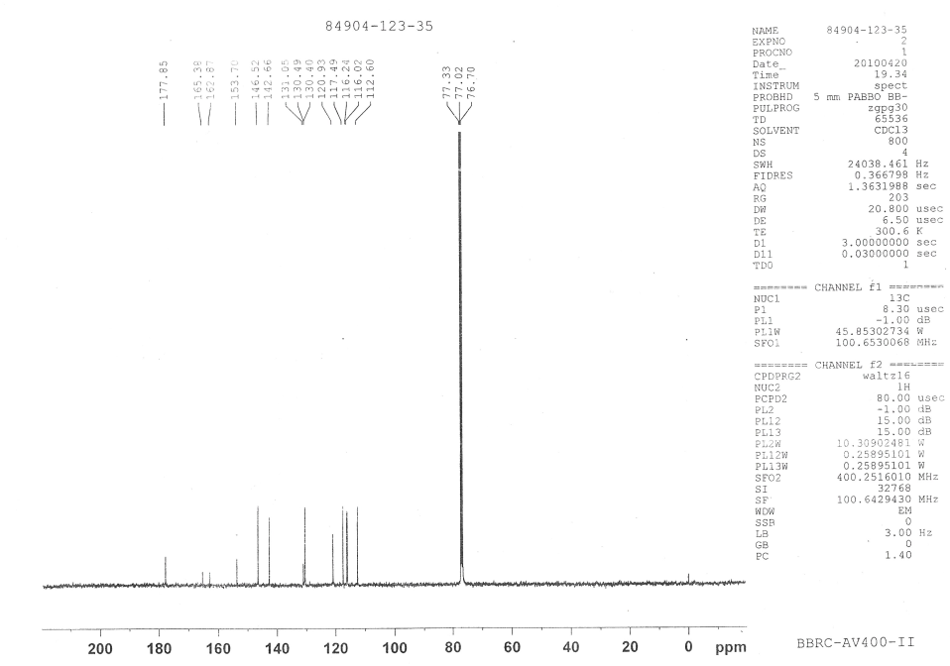

**Figure 2.39**  13C NMR spectra of (E)-1-(furan-2-yl)-3-(4′ -fluorophenyl)prop-2-ene-1-one

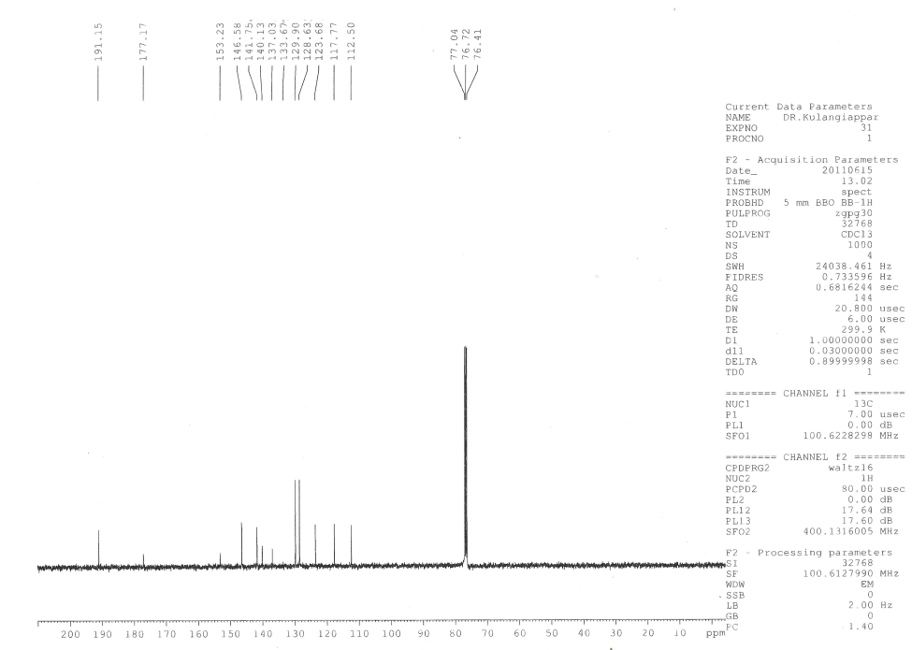

**Figure 2.40** 13C NMR spectra of (E)-1-(furan-2-yl)-3-(4′ -methanoylphenyl)prop-2-ene-1-one

* 1. **Antibacterial activity measurements**

Agar well-diffusion method was followed to determine the antimicrobial activity.4 Nutrient agar (NA) and Potato Dextrose Agar (PDA) plates were swabbed (sterile cotton swabs) with 8 hours old -broth culture of respective bacteria. Wells (6 mm) were made in each of these plates using sterile cork borer. Briefly, agar plates were inoculated with bacterial strain under aseptic conditions and wells (diameter = 6 mm) were filled with 50 µl of the test samples and incubated at 37°C for 24 hours. After the incubation period, the radii/diameter of the growth of inhibition zones were measured. The distance between the center of the well to the edge of the zone was determined to be the inhibition zone radius. The distance between the edge to the edge of the zone was determined to be the inhibition zone diameter. Three inhibition zone radii/diameter measurements were taken for each well and averaged, for each replicates the readings were taken in three different fixed directions and the average values were recorded. The average inhibition zone radii/diameter for the various bacteria were measured.

**2.5 Cyclic voltammetry measurements**

In this study acetonitrile containing tetrabutylammonium tetrafluoroborate (TBATFB) as a supporting electrolyte has been used as the medium. Throughout the study, oxygen is completely removed from the cell by purging and blanketing nitrogen gas for a minimum of half an hour. After checking the deoxygenation by running a background cyclic voltammogram, the substrate is added and cyclic voltammograms were recorded. The cyclic voltammograms of (E)-1-(furan-2-yl)-3-phenylprop-2-ene-1-one in acetonitrile at various concentrations and at various sweep rates were recorded. The sweep rate has been changed from 20 mV s-1 to 160 mV s-1.

**2.6 References**

1. A.M. Islam and A.A. Khalaf, Indian *J. Chem*., **7**, 546-549 (1969).
2. S.Branko and A.Jursic, *J.Heterocyclic Chemistry*, **38**, 655-657,(2001).
3. Adam’s, Johnson. Wilcos, *Lab exp Org Chem*, 361-364,(1970).
4. V.Chandra Sekar, S.J. Knabel and R.J. Anatheswaran, *Food Sci Nutri*.,**3**,394-403,(2015).